**Good Generic Programming Problems**

**Problem 5** (*Generic Programming*) In your package prob5, create a class Lists that contains generic helper methods for processing lists. Your Lists class should contain two public static methods:

toList - Produces a parametrized list from an unspecified number of arguments. Your toList method should be able to produce (at least) the following outputs:

List<Integer> myList1 = Lists.toList(1,3);   
List<Number> myList2 = Lists.toList(2.3, 4, 3.7f);   
List<Comparable> myList3 = Lists.toList(“2.3”, 4.5, 9);   
List<Object> myList = Lists.toList(new Employee(“Joe”, 200000), “Alice”, 75, 3.33);

Think of the most general signature and return type for your toList method and then implement.  
*Warning:* Your implementation may not make use of the Java library method Arrays.asList.

String toCompressedString(List<?> list) – Transforms each element of the list to a String and then concatenates these Strings and returns the result. Examples (using list examples above):

Lists.toCompressedString(myList1) //outputs 13  
 Lists.toCompressedString(myList2) //outputs 2.343.7  
 Lists.toCompressedString(myList3) //outputs 2.34.59

You must use the type shown for the input list, namely, List<?>. You will need to use a technique discussed in class to handle Lists of this type.

*Hint*: The toList method needs to take a varargs argument. Here is a simple example of a method that is defined in this way:

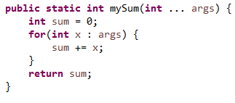

Usage:  
 int x = mySum(3, 7); //value stored in x: 10  
 int y = mySum(1, 1, 4, 5); //value stored in y: 11